Introduction Talk Notes for aaBridge
for how to download/install see web site ( or just google aaBridge )
https://sites.google.com/view/rogerpf-com/aaBridge and read the
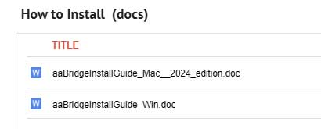
Think of aaBridge as a Juke box – the “records” are
Deals (lin files) in the drop down Book menus
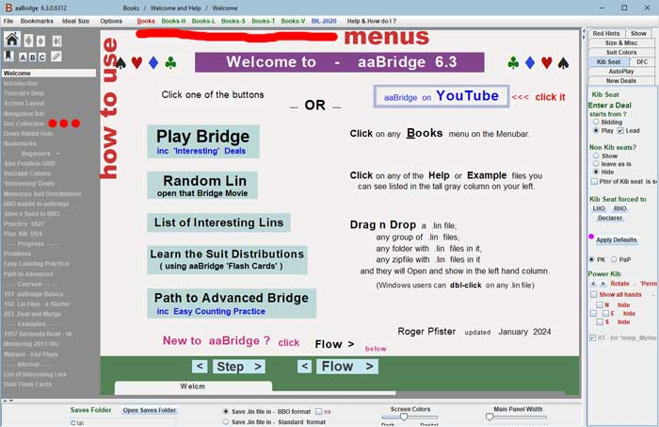

The 3 KEY Points of the talk

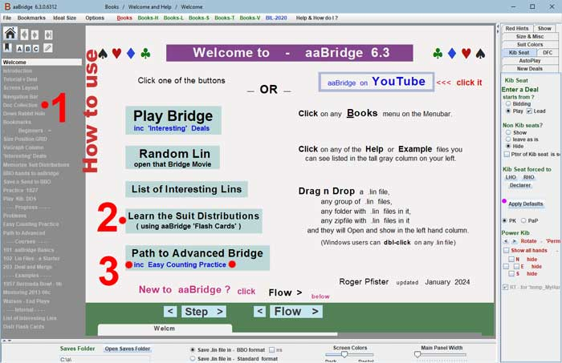

1. How to Use . . . (analyzing your play)
the Doc Collection is your friend
2. Learn the Suit Distributions
( learning to count )
3. Easy Counting Practice

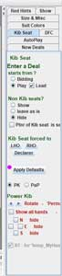
Parts of the Front (Welcome) page

Side and lower “settings” panels
For easy settings ignore them until useful
How do you know when they are useful ? – the documents will tell you

Hover for a pop-up
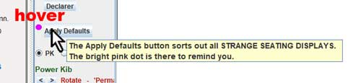

Many buttons and controls have helpful pop’s if you just Hover
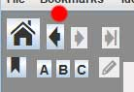
Home and Back control area
the back button (red dot) is the . . .
“Help, how did I get here – take me back” button
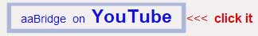
YouTube

Bookmarks etc. …
covered under “How to use”
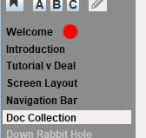
How to use
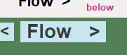
Starting from the Welcome screen (red dot)
you should read each page in turn clicking the
Flow > button or better still your mouse
wheel as you move through the brief explanations of the many parts of aaBridge.
In particular Tutorial v Deal page explains that there two types view of a bridge deal, this is also covered later in Down the Rabbit Hole.
Doc Collection
This is core – the center of the aaBridge Help system.
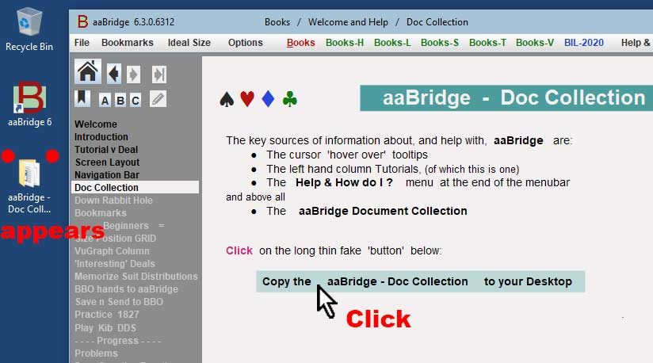

When you click the “button” the aaBridge Doc Collection folder will appear on your desktop. (On a crowded desktop you may need to hunt for it.)
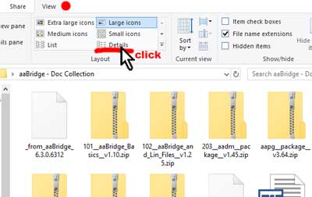
When you double click the aaBridge Doc Collection icon (it is a folder).
It should open and my look something like this – see on the right (Win 10).
I do not find this “view” at all use useful. so . I click the View tab (red dot) and then click on Details. Underlined in the image on the right.
(Google if you have a different OS).
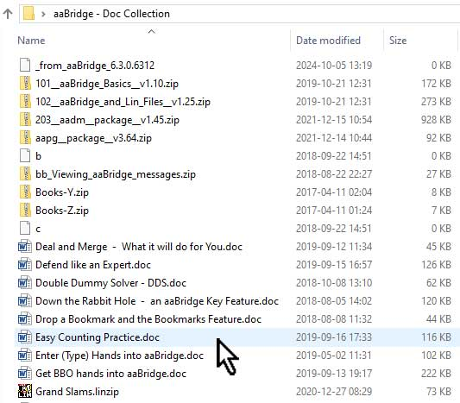
After that the Doc collection should
look more like it is shown in the image on the right.
There are many more files that those shown here.
These files are the treasure trove
of aaBridge Help & How To.
For example the cursor is in the image shown pointing at -
Easy Counting Practice.doc
which is the Big Red Point # 3 mentioned at the start of these notes.

One thought
If you find yourself struggling with a feature of aaBridge -
it may pay you to look through the titles of the files in the Doc collection.
Bookmarks as an example

If you want to know about bookmarks. You can –
click on Bookmarks in the menubar
or hover over the Bookmark icon
or click on the Bookmarks entry in left side panel
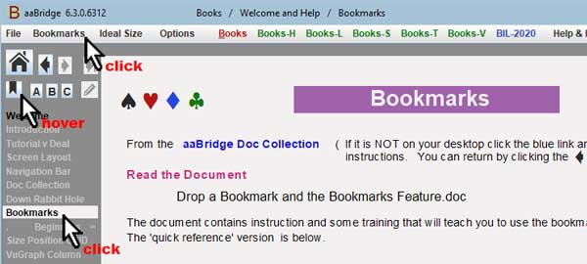

all of these (try them) have different levels of information.
The third option (shown above) at first directs you to the
aaBridge Doc Collection
and then to the
Drop a Bookmark and the Bookmarks Feature.doc
That document full of diagrams and explanation so there is no point in me reproducing any of it here.

Down the Rabbit Hole
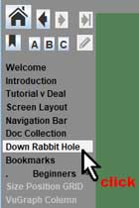
If you are new to aaBridge you have (I hope) already looked at and read
Tutorial v Deal & Navigation Bar
Now select Down the Rabbit Hole and of course
go to the Doc Collection and read the document.
Down the Rabbit Hole – an aaBridge key feature.doc
don’t forget to step / flow through the 7NT example that is under this heading in aaBridge. Of course you will press the Enter the Deal button and hopefully you will get to see things like –
Once you are inside a deal, the step button shows a whole trick at once whereas the flow button plays each of the four cards one after another.

By now you should have the skills to be able to look at tutorials that are inside aaBridge for example click the menubar item
BIL-2020 and select Karen10
The second entry in the left-hand bar is Karen on Finessing

Can you play through it ? does it work for you ?
Does clicking Enter the Deal makes sense to you ?
BBO hands to aaBridge
Getting the BBO hands that you have played into aaBridge.
This is covered by the left panel entry BBO hands to aaBridge.
This directs you to two videos (I won’t repeat their numbers and names here that’s what left-hand panel is for) and to a document from the Doc collection called
Get BBO hands into aaBridge.doc

What follows is a section from that document but best to read the original.
First open aaBridge
In your browser go to the BBO front page.
and Click HAND RECORDS.
If you have “Remember Me” checked in BBO you don’t get a chance to see the that front page.
In that case, when in BBO use their Log off button, then when you rejoin BBO you will see their front page.
OR just click https://www.bridgebase.com/myhands/
You may then need to Login to BBO
Next (see image) set the time period you want hands from (you can also get hands other users, as in this example )
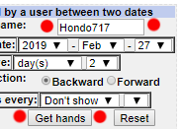
On the screen enter the name of the user who played the hands and select the dates between which they were played.
Here the user is set to the teacher Hondo717.
Hint – you can select a whole month and not just days(s).
Click the Get hands button (red dots)

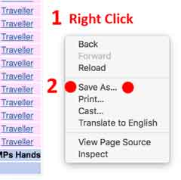
Once the list of hands is showing.
On Windows (and Mac) you can
1. Right Click in the white area.
2. Click Save As... (red dots)

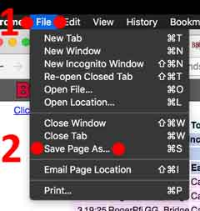

Or on a Mac ONLY
using Chrome's File menu
1. Click File
2. Click Save Page As.. (red dots)

Both methods will open Chrome's Save As dialog.

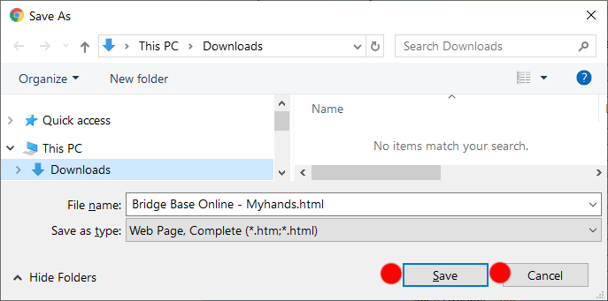
Click Save (red dots)
and if needed say – Yes you want to override the existing file with that name.
That is it …you are done !

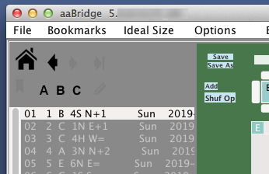
The downloaded hands will now show in aaBridge.
See Example on a Mac →

1

Using aaBridge to Analyze Deals
(including your own)
Videos on YouTube
004 Using the DDS and Analyser in aaBridge
008 Using ‘Shuf Op’ and the Analyser in aaBridge

The Doc Collection doc to read is
Double Dummy Solver – DDS .doc

So you have got a deal (at least one) into aaBridge.
You would like to know if you played the hand well.
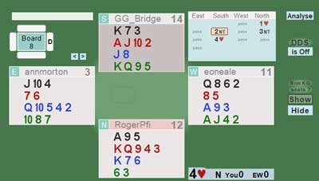
A quick example
Below is a hand I (mis-?) played and went one down, when almost everyone else made it.
Click the Analyse button (top right) and the possible contracts and result of best play by both sides will show.
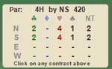
So we can see that - yes North can make 4 hearts.
First turn on the DDS (Double Dummy Solver)
i.e. Click on “is Off” under DDS on the upper right.
Now can repeatedly click the Flow > button (or better still, use the mouse wheel) and watch to see where I (declarer) went wrong.

Once you get to trick 7 my error is revealed.

I played the 6 of Diamonds and so lost two Diamond tricks.
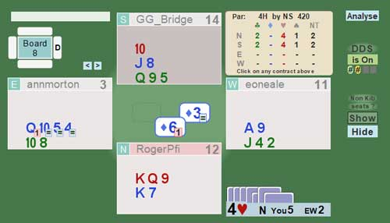
You can see that the Diamond 6 shows a pink “1” which means I am now going one down. Putting on our bridge hats and looking back at the initial deal you can see I have one Spade loser, one Club loser and must avoid two Diamond losers.
Actually on this hand I think credit must go to the defense because when my RHO led three of diamonds she had shown up with six hcp whereas her partner had only shown one, the Jack of spades. So I decided that it was more likely that LHO was going to be holding the ace of Diamonds and therefore played low. Well done to the defense.
While this is a deliberately simple example it’s here to show you how to use the DDS when you want to what the computer thinks the best line would be.

Playing the Hand again
You can also use aaBridge to play the hand again and even move some of the cards about and play it again.

But for that I’m going to refer you back to the videos and documents listed earlier.

What is Counting the Deal ?
The final two red numbered points (2 and 3) are all about learning to count the deal. Counting the deal means that when possible early on during the play of the hand you end up knowing –
- How many cards of each suit remain in the unseen hands.
- Where the unseen high cards are around the table.
To put it honestly, doing this is very hard. Incidentally, once you start to be able to do the first point you are turning in to an advanced Bridge player.
That is really all there is to it, advanced bridge players can “get the count” others can’t.
The next two sections concentrate on a) above. Getting the distribution of the suits in the unseen hands. Point b) above will come quite easily after that.
If you are starting out on your bridge career then being able to do this will sound nearly impossible. It is for that reason aaBridge has the next two features (2 and 3) built into it.
Think of them as a compact stepladder where the steps are only a small distance apart and easy to stand on. The idea is that with occasional practice you can slowly build this skill.

Practice suggestion
One suggestion I have is that particularly with more realistic practice given in section 3 you and your bridge partner when playing online, do this together.
One of you shares your screen and steps through the hand you are trying to “get the count of”. At some point you can stop and compare ideas of the distribution of the unseen hands. This may not sound much like fun, but you may be pleasantly surprised.

Learning the Suit Distributions
2

Learning by physically writing out the distributions is covered by the left-hand panel entry (recommended) a great start to your learning.
Memorize Suit Distributions and its associated .doc
The point of all this activity is to get your unconscious competence to supply you the answer to the questions like those shown below -
What is the missing number
3 ? 4 1 2 4 ? 1 5 2 ? 3
The key skill to be able to fill in the blanks without having to add up anything. This skill will come to you faster than you expect but you have got to practice it.
You will learn much faster if you follow the advice in the document above and physically write out the common distributions.

Using aaBridge
Learning by using aaBridge is best covered an old video
(listed at the end of the YouTube videos)
Old - Learning to count the unseen Hands using aaBridge
RECOMMENDED
and partially in the document Easy Counting Practice.doc
I suggest you start by playing the video.

The ‘Flash Card’ system
The ‘Flash Card’ system works in two modes Train[ing] and Exam
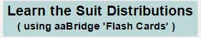
Click the button on the Welcome page.
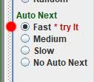
In the Auto Next settings set select Fast (red dot)
Note you are in training mode, the Train button is WHITE.
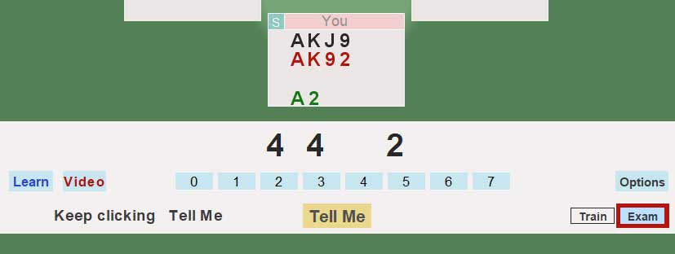
Keep clicking Tell Me and the missing length will show. I like to say the answer out loud first. This way you can work up a reasonable speed.

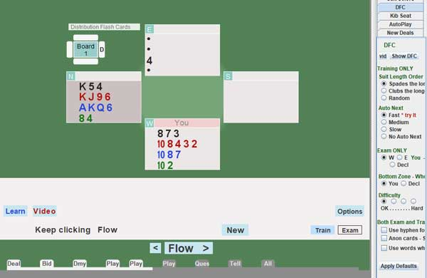
Exam Mode ( click the Exam button )
In exam mode you are slowly shown information about the other hands and need to work declarer’s shape.

See the video above for an example of it in use

Many options are available on the Right - as always, hover is your friend.
Now watch the video
Old - Learning to count the unseen Hands using aaBridge
3

Easy Counting Practice

Normal starting point for this is by clicking on the left-hand panel entry
Easy counting practice and reading its associated .doc

There is also a YouTube video that includes examples
015 Easy Counting Practice

The essence of this method of using aaBridge is to use aaBridge to view preselected hands in which both sides contest the bidding.
Given that you can also of course your own hand the idea is to try to deduce declarer’s shape just from that information.
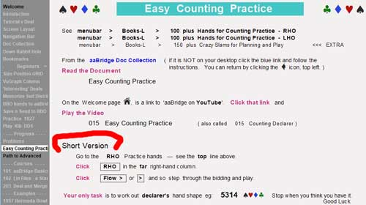
One huge advantage over real bridge is that you have no decisions to make all you have to do is watch and count the hand.
The left hand panel entry contains a Short Version as a quick reminder of what to do in future sessions.
The hands are provided in sets see
Menubar > Books-L > 100 plus Hands for Counting Practice – RHO
" " " – LHO
Best to start by sitting in the RHO seat (relative to the declarer).
For more sets of hands like these see under Books-V
When you first open any set of hands you will again see a reminder
As to how best that of hands
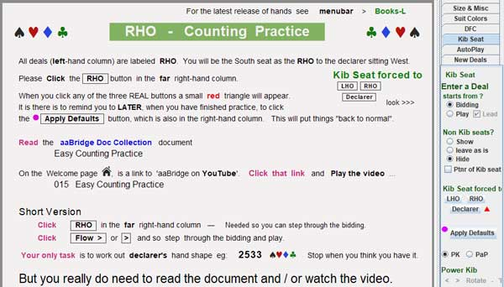

All I am going to do now is to reiterate the advice shown at the bottom of the image above
Read the document
and most importantly go and watch the video

015 Easy Counting Practice

Thank you for reading.
Roger Pfister

